**Deploy in kubernetes cluster**

|  |  |
| --- | --- |
| Team ID | PNT2022TMID50023 |
| Project Name | Plasma Donar Application |

**Create a Kubernetes cluster**

* Sign in to your IBM cloud dashboard.

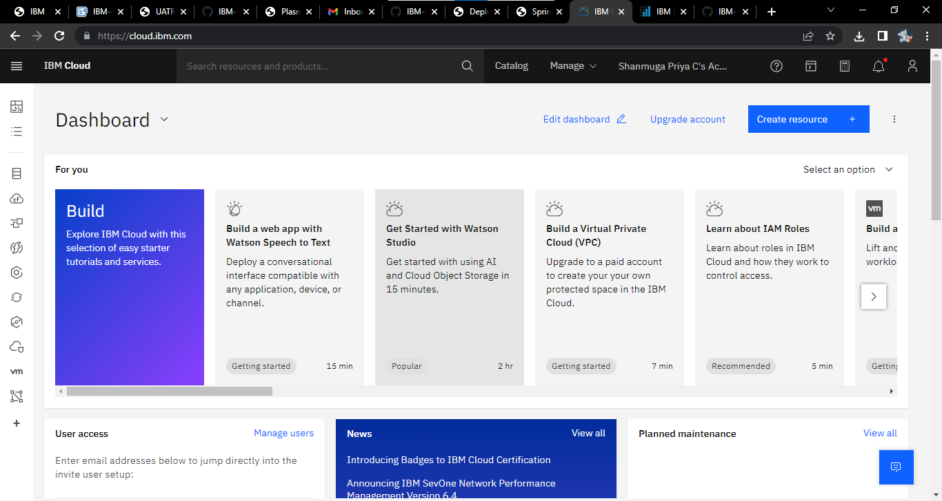

* Open IBM Kubernetes Service.
* Click Create Cluster.

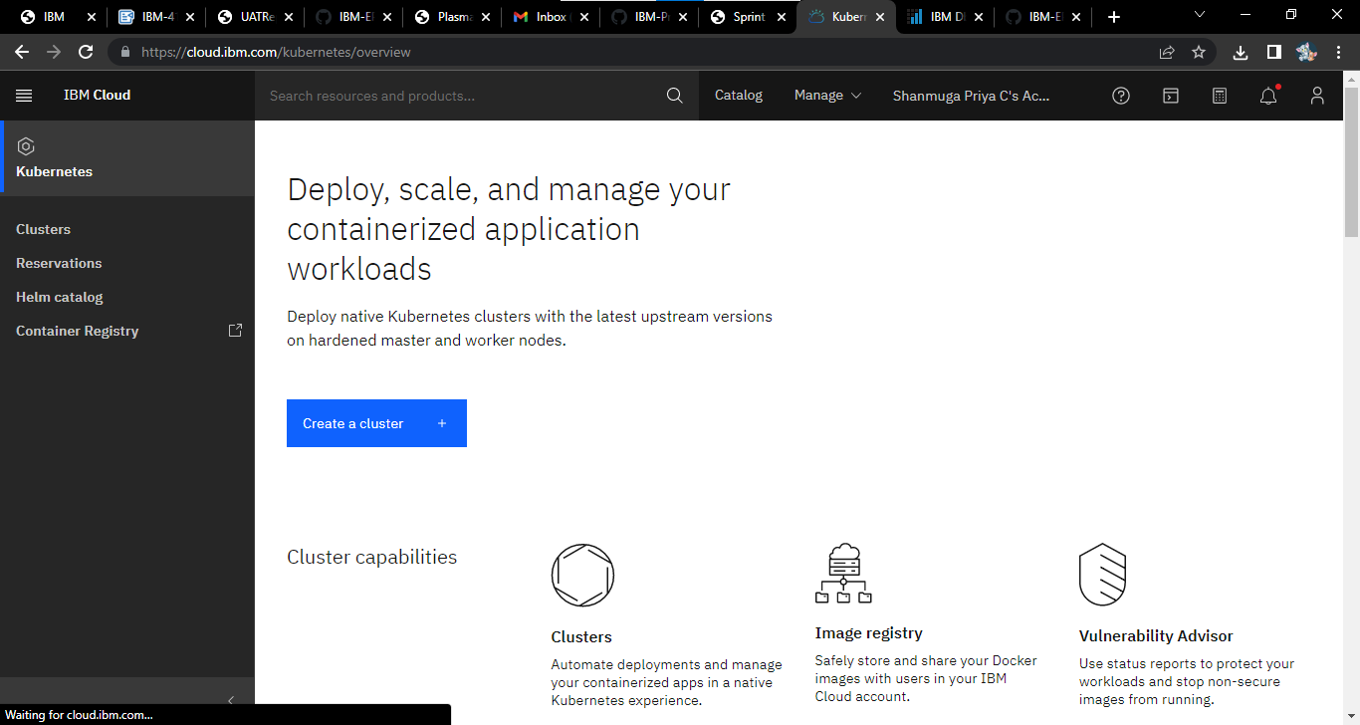

* Select the Region where you want to deploy the cluster, type in a name for your cluster, then click Create Cluster.
* Select the appropriate cluster type depending on your account.
* It takes some time for the cluster to get ready (around 30 minutes)